**Assignment No.1**

Name: - Bhavin Ratansing Patil

Roll No.: - 26 SEDA

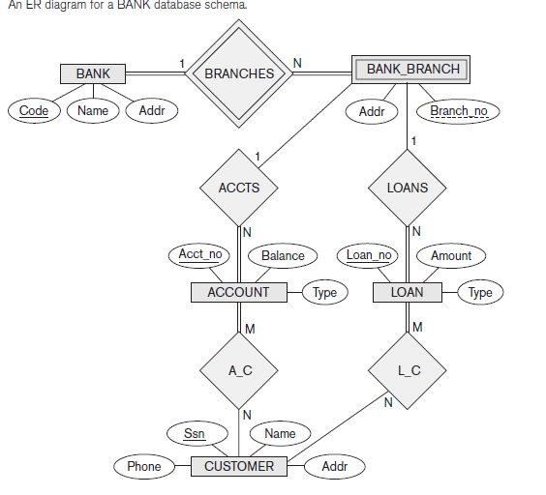**Que 1. Consider the ER diagram shown in Figure.**

**a. List the strong (non-weak) entity types in the ER diagram.**

Bank, Account, Customer and Loan

**b. Is there a weak entity type? If so, give its name, partial key, and identifying relationship.**

Bank Branch is the weak entity and it’s partial key is branch_no. and

relationship is branches.

**c. What constraints do the partial key and the identifying relationship of the**

**weak entity type specified in this diagram?**

Bank_branch cannot exist without associate bank.

**d. List the names of all relationship types, and specify the (min, max) constraint on each participation of an entity type in a relationship type. Justify your choices.**

Bank – branches – Bank_branch (1:N)

Bank_branch – accts – Account(1:N)

Bank_branch – loans – Loan(1:N)

Account – A_C – Customer(M:N)

Loan – L_C – Customer(M:N)

**Que 2. For each of the following pairs of rules, identify two entity types and one relationship. State the cardinality and existence of the relationship in each case. If you don't think enough information is available to define either of these, then state an assumption that makes it clear. Draw the ER diagram.**

1. A department employs many person. A person is employed by, at most, one department.

1 M

employs

person

Department

1. A manager manages, at most, one department. A department is managed by, at most, one manager.

1 1

Manages

Department

Manager

1. An author may write many books. A book may be written by many authors.

M M

Write

Books

Author

1. A team consists of many players. A player plays for only one team.

1 M

Consists

Players

Team

1. A lecturer teaches, at most, one course. A course is taught by exactly one lecturer.

1 1

Teaches

Courses

Lecturer

1. A flight-leg connects two airports. An airport is used by many flight-legs.

M M

Connect

Airports

Flight-leg

1. A purchase order may be for many products. A product may appear on many purchase orders.

M M

Purchase

Product

Order

1. A customer may submit many orders. An order is for exactly one customer.

1 M

Submit

Order

Customer

**Que 3. Draw an ER diagram for the following application from the manufacturing industry:**

1. Each supplier has a unique name.

2. More than one supplier can be located in the same city.

3. Each part has a unique part number.

4. Each part has a colour.

5. A supplier can supply more than one part.

6. A part can be supplied by more than one supplier.

7. A supplier can supply a fixed quantity of each part.

**supplies**

1 M

Parts

Supplier

**Que 4. Use an Entity-Relationship diagram to depict the information needs of the following engineering enterprise:**

- Each engineer works on a number of projects. For every engineer a record is kept of his/her number, name, title and salary.

- For every project a record is kept of its number, name, budget and location. Additionally, the responsibility each engineer has on a particular project and the amount of time spent on the project is noted.

- Clients contract these projects. The client's name, address and phone number must be recorded.

The contract date, i.e. the date at which the client signs the contract for a specific project is also noted.

- A record is also kept of the machinery being used for a particular project. The name, amount and the date the machinery is needed for the project is recorded.

Include any attributes you think should be represented (state why). State any assumptions you have made.

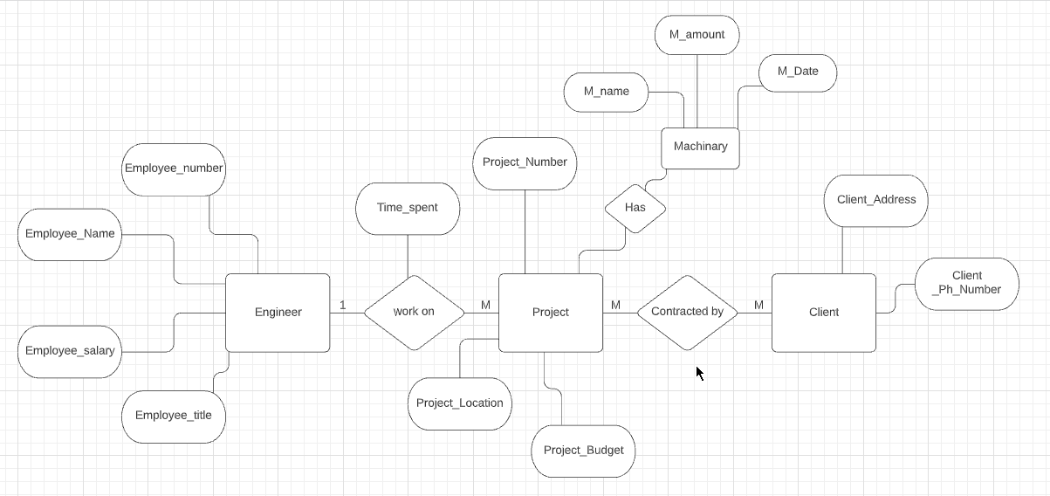

**Que 5. Consider the following information about ‘Johnny’s Bakery’:**

• ‘Johnny’s Bakery’ makes a number of different products including breads, biscuits, cakes, pies, and many other baked goods.

• Ingredients such as flour, sugar, salt, butter, milk and so on are purchased from vendors.

• Sometimes an ingredient is purchased from a single vendor, and sometimes an ingredient is purchased from a number of different vendors.

• The bakery has commercial customers like schools, colleges, and restaurants that regularly place orders for baked products.

• Each baked product has a product manager who looks after the setup of the bake operation and inspects the quality of the finished product.

• Attributes of vendors include vendor_id, vendor_name, vendor_phone_no, vendor_mobile_no, and vendor_city.

• Attributes of ingredients include ingredient_id and ingredient_name.

• Attributes of commercial customers include customer_id, customer_name, and customer_phone_no.

• Attributes of product include product_id, product_name, and product_manager_id.

• Attributes of product manager include product_manager _name, product_manager_id, product_manager_phone _no, product_manager_mobile_no, and product_manager_office_no.

Draw an Entity-Relationship Diagram (E/R Diagram) for ‘Johnny’s Bakery’ (you can make any assumptions you need, but state them clearly).

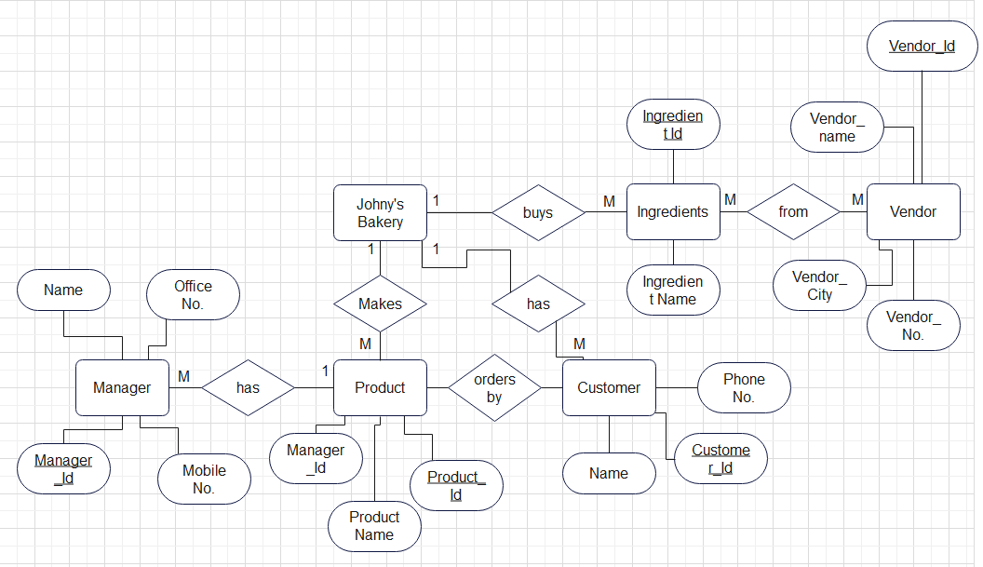

**Que 6. Use an Entity-Relationship Diagram to depict the following requirements for a restaurant:**

· The restaurant employs a number of chefs. A record is kept of each chef’s name, address, phone number and salary.

· Each chef can prepare a number of meals. The name of the meal and the price of the meal is recorded.

· Each meal consists of a number of ingredients. The name of the ingredient and the quantity required for that particular meal is recorded.

· These meals are ordered by customers. A record is kept of the customers name, address

and phone number. A record is kept of the time and date the meal is ordered.

State any assumptions made in the design of the E-R diagram



